**Experiment No. 01**

**Software Requirement Specifications**

**Contents:**

1. **Introduction**
   1. **Purpose**
2. **Intended Audience**
3. **Project Scope**
4. **Overall Description**
   1. **Product Perspective**
5. **Definations**
6. **Product Features**
7. **Use Case Diagram**
   1. **Hardware Interfaces**
   2. **Software Interfaces**

**8. Level of Access**

**9. Top Level Requirements**

**9.1 Functional Requirements**

**9.2 Non-Functional Requirements**

**1.Introduction**

|  |  |
| --- | --- |
|  | Staysafe Security System ensures safety of the students by making their parents aware about the various important status about their students like in-time, out-time, everything about the arrivals and details of their child.   * 1. **Purpose**   The main purpose of this specification is to help people who will work on this system to maintain the objectives and get started working in this project. This specification will direct people who will work on this project step by step through the process until they finish it successfully. This statement will describe specific details into every step of this project that workers will immediately locate the needs of this system to understand the purpose of doing any of the following steps into the system. |

1. **Intended Audience**

|  |  |
| --- | --- |
|  | The audience of this system will be:  1. Students  2. Faculty members  3. Registration office  This project will be managed by registration office, created and developed by the IT staff and other specialized people in the technology, such as programming, web design and others. |

1. **Project scope**

|  |  |
| --- | --- |
|  | The scope of the system is to have a high-tech environment in the Dominican university community. That means by using the automatic attendance system, the community will transfer to the technical environment that they already have the Canvas system to help them manage the courses they have in the whole semester. This system will add some features in the automatic attendance system to Canvas by using fingerprint device in every classroom at Dominican University.  3.**Overall Description**  **4.1 *Product Perspective***  At Dominican University, instructors manually take attendance in every class each day. They spend time to do that during class time. The Automatic Attendance System will help them do this process in an easy way. The main scope of this project is to make attendance process more organized in every class. This project will help instructors take the attendance automatically without spending some time during the class. It will provide the instructor who is/isn't present an early-warning of high levels of non-attendance through the Canvas page. There are also many benefits for students: they can manage their attendance, absences, and late walk-ins by checking the Canvas site. They will also know the current grade in their reports. It makes it easier to have a clear picture of every student’s attendance throughout the academic year.  The system is about to modify an existing system to develop the project. This system comes from Instructure. Instructure is a new company that has 200 employees. This company is an educational origination that works with technology to help the education community in an effective way. This company provides Canvas. The Canvas system is about a website page, which contains classes managed by instructors. It has management tools for courses. These tools play a significant role in the educational models these days, which are to organize the educational level using technology to achieve the educational goals easily. Instructors have the control panel for every class they have. The control panels allow them to create and develop the course’s page that all students can see. They may have a Home Page, Syllabus, Discussion, Grade, Assignments, People, Files, and more. All of these components are available and controlled by the faculty member to make any changes.  **5**.**Definitions**  **Users**: This means students who will get the most benefits of the system.  **Faculty:** Also, who has the top priority to get benefit for the system and they are the target actors of the system.  **The Registration Office**: This is for the system management, and it will be presented by the employees. |

6. **Product Features**

There are two kinds of process models for this system. There is the overview process modeland the conditional process model. Starting with the first one. The first step of this process is tohave a fingerprint capture device. That will do the following steps:

1. Students enter their fingerprints into the device.
2. Every fingerprint has a special code number for every recode. This code number takes theother step, which is matching.
3. The system checks on the fingerprint and sends to the server and the student database.
4. In this database file, the system checks this print for the identification. Also, the database sends it to the registration office data file to check if this code exists or not. If the code numberfor the fingerprint is in both databases, the code number will continue for other steps. And if the code is not there, it will give you a false result. Then, it will send you to the registration office forthe identification and look for your record to modify it if there is any issue. Then, students will tryagain.There is another step after the general identification.

Checkpoint, which will check if the student data is enrolled in the particular class or not. If yes, the process will continue, and if not, the system will send you to the registration office to check.

After that, the system now has access to the Canvas system. The system will access thestudent’s attendance page where it can take the attendance through the Canvas pageautomatically. The last step of this process is to send a notification message to students andfaculty. Students can check on that and know their attendance grade. Faculty will have all students’ attendance reports, and they know who is attending and who is not.There is also another process for this project that if a student missed a class, the system wouldmake a decision. The aim of this process is to contain every student’s status and make sure the attendance for all students has already been taken. After ten minutes of the class time, thesystem will run automatically to check on the attendance page. If all students attended in thatclass, the system will send a report to them and stop.However, if there are students who missed the class, the system would start some process. The system will check for who is missing the class and make a list of them. Every student of this listwill receive a message that asks them for the reason of the missing the class. In this step, thesystem will wait for getting a response from each student separately. If the student answers withyes, and writes a note for it, the system will send this message to the faculty member. Thefaculty member has all the right to accept the excuse or not. If a student does not have a reasonfor the missed class, and checks on no, the system will count the missed class and send areport. Furthermore, if the student has an acceptable reason that he/she provides to faculty, thesystem will automatically report them, and the system will be done.

**7. Use Case Diagram:**

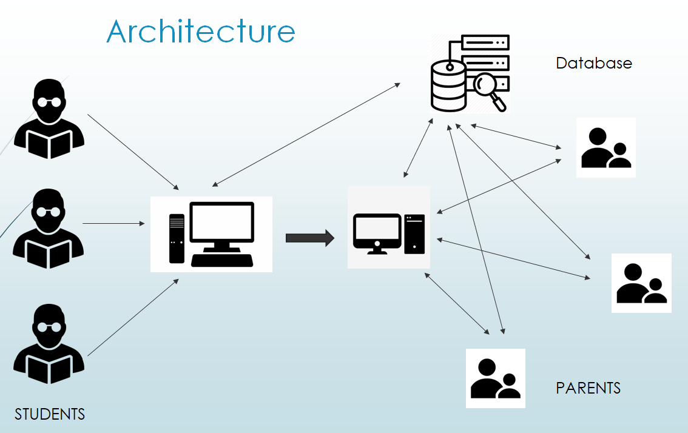

**7.2** **Hardware Interfaces**

The hardware environment in this system will use the Biometric Fingerprint Scanners. Thesescanners will play a role in the system. This device must be available in every classroom in theschool. Also, it must be in the registration office. The interfaces for the hardware part are thesame in the registration office’s interface. This part of the interface has also other components, such as student’s information, faculty information, class’s information, and other related information. All of these data are stored in the database and end with the device screen andweb pages.

**7.3 Software Interfaces**

The system will use:

1) Biometric Fingerprint Devices display software

2) Web pages for the forms HTML, PHP

3) Server

4) Programing using JavaScript

5) Database uses with mysql.

**8 Level of Access**

**Subject:**

**Parent Module**: Parents can access their child details on web based portal.

**Student Module:** Needs to login to the software Application by scanning the QR code on ID card.

**9 Top level requirements**

**9.1 Functional Requirements**

The system should support management of academic, administrative and other activities in our institute. These activities are divided into four sections as follows.

• Academic Activities

• Administrative Activities

• Accounting and Finance

• Facilities

* Academic activities include:

1. Academic Programme : Applications and Admissions, Enrolling new students, Course registration (enrollment for desired courses) and Fee payment, Evaluation and Grading, Viewing and printing grade cards, Teacher evaluation.

2. Student Information : Student records management.

3. Training and Placement : Displaying schedules of Campus interviews, Putting up shortlists and declaring results.

* Administrative activities consist of:

1. Employee Information : Maintaining Employee records, Accessing data and Generating reports as required.

2. Legal matters : Access to Case reports and Legal suits of the Institute.

3. Human Resources Management : Faculty and Staff Recruitment Process

4. General Administration : File movement Tracking (across departments/administration), Facility to raise an issue / ticket and track it, Meeting Management, Managing Institute Advertisements.

* Accounting and Finance includes:

1. Student account management covering fees, teaching assistantship, scholarships, f ines and other charges

2. Employee Accounts Management: Salaries, Leave management, Income Tax management, Pension management, TA/DA and PDA.

3. Visibility and transparency of various funds across departments, projects, interest groups, Deans,Registrar and the Director; Compilation of accounts to enable furnishing details of expenditure to the funding agencies.

* Facilities include:

1. Stores and Purchases : Indenting and approval, Billing and sales, Inventory management and stock verification, Common Access System to Library, Stores etc through Smart Card, Interface to check stock register and status of purchase etc.

2. Infrastructure Facilities and Transportation : Student hostel/room allocation, Hostel management,Guesthouse management, Apartment/Quarter allocation and management, Managing the booking of Seminar Halls / Conference Rooms, Transportation management, Civil Maintenance works, Water / Electricity Bills, Electrical Maintenance.

**9.2 Non-Functional Requirements**

* Deployment:- System should be locally deployable at NIT Calicut, preferably on a Linux platform.
* Security:- Nobody should be allowed to tamper with data; Enhanced Security for sensitive data. It should be made sure that only users who are given specific rights can access data and all actions are logged, thus providing an extensive role based authorization.
* Backup:- There should be an easy back-up feature for the entire data, to prevent losing any data.
* Platform/Browser independence:- The system should be able to work on any of the modern browsers like Firefox / Explorer / Opera /Chrome, and any of the common Operating Systems like Linux, Windows and Mac OS.
* Data migration:-

(i) There should be an easy way to migrate data from the current system to a new system.

(ii) The system should be able to interface with Microsoft Excel – read from Excel and write to Excel.

* Performance

(i) During Course Registration an estimate of 10,000 students should be able to register over an interval of 2 days.

(ii) The system should handle the simultaneous usage of almost 1000 users at a time.

* Flexibility:- As many of the institute processes and rules are expected to evolve over time, an important requirement for the software is customizability. It is desirable to have a system that is flexible enough to allow theadministration at NIT to evolve our processes without having to contact the company every time for any small change. For example, adding new attributes in the registration form.
* Ease of use and Documentation

(i) The software should be designed for extensive customizability, even for people who are not used to computer programming.

(ii) The user-interface should be intuitive and easy to navigate.

(iii) There should be a proper documentation of the system. This document should be so simple yet precise so that a newly appointed faculty should do all the things on one’s own and distinguish all the features. This could be given in the form of a ‘help’ menu associated with every activity.

* Components:- It is desirable that the solution must be based on, and runs on open-source infrastructure and components, such as Linux, Apache Web Server, Tomcat/JBoss, PostgreSQL/MySQL. The solution can be composed from available open source components and custom developed ones. Any custom components developed should be made available to NIT Calicut in the source format with sufficient documentation.